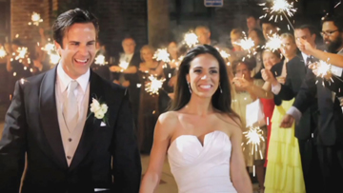
leone productions 404-312-0343 www.leoneproductions.net
120 Clarkewoods Road, Athens, Georgia 30607
Based in Atlanta and Athens… Serving all of Georgia and out of state

With Leone Productions videography you will receive so much more beautifully filmed footage; all professionally produced for your DVD or Blu-ray copies with menu choices.

PACKAGES: We also offer CUSTOM video packages... Raw Footage and Highlights Video see Below!

Silver Package - $750
- 3 hours coverage (you choose our start and end time)
- 3 DVD or Blu-ray copies, with menu choices (ex. preparations, ceremony, reception)
- Full Ceremony as one of your menu choices; recorded with wireless mic for clear audio
- Introduction Photo Montage (mainly stills I create of your decor details); set to music
- With menu choices you receive approximately 1 hour of beautifully edited footage
- Add a 3-5 minute Highlights video, set to music of your choice, for $150; on DVDs & Posed on-line

Gold Package - $1,100
- 5 hours coverage (you choose our start and end time)
- 3 DVD or Blu-ray copies, with menu choices (ex. preparations, ceremony, formals, reception)
- Full Ceremony as one of your menu choices; recorded with wireless mic for clear audio
- Introduction Photo Montage (mainly stills I create of your decor details); set to music
- With menu choices you receive approximately 1& 1/2 hours of beautifully edited footage
- Add a 3-5 minute Highlights video, set to music of your choice, for $150; on DVDs & Posed on-line

Platinum Package - $1,650

- 7 hours coverage (you choose our start and end time)
- 3 DVD or Blu-ray copies, with menu choices (ex. prep., ceremony, formals, reception, Highlights)
- Full Ceremony as one of your menu choices; recorded with wireless mic for clear audio
- Introduction Photo Montage (mainly stills I create of your decor details); set to music
- With menu choices you receive approximately 1&1/2 to 2 hours of beautifully edited footage
- A 3-5 minute Highlights video, set to music of your choice, is included on DVDs & Posed on-line

The Cinematic - $2,600

- Up to 8 hours coverage with 2 videographers (you choose our start and end time)
- 5 DVD or Blu-ray copies, with menu choices (ex. prep., ceremony, formals, reception, Highlights)
- Full Ceremony as one of your menu choices; recorded with wireless mic for clear audio
- Introduction Photo Montage (mainly stills I create of your decor details); set to music
- With menu choices you receive approximately 2 hours of beautifully edited footage
- A 3-5 minute Cinematic Highlights video, set to music of your choice, is included as another menu choice... And posted on-line for you and your guests to view

Example of DVD or Blu-Ray menu Choices:

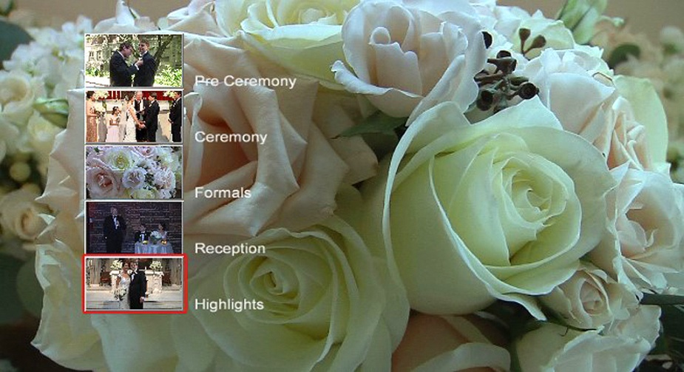

RAW FOOTAGE ONLY: Received on a USB Flash Drive... $100 per hour of coverage time (4 hour minimum); with 1 videographer. A second videographer is available for $100 per hour

HIGHLIGHTS VIDEO ONLY: Receive a 3-5 minute Highlights video, set to music of your choice... $250

NOTE: Please let me know if there is anything else about my videography I can answer for you.
Custom video packages available.

CONTACT: Joseph Leone 404-312-0343 mailto:info@leoneproductions.net http://www.leoneproductions.net

Payments: A 30% retainer fee is required to reserve our wedding videography services for your wedding day.
Balance is due on or prior to your wedding day. Payments can be made by check, or Credit Card (LINK)

LINK to CONTRACT PDF file: Simply fill in the blanks to book your Videography

Additional Options:

Extra DVDs: $20 per copy... Blu-ray Disks: $25 per copy

Growing Up Photo Montage: From baby, to growing up years, to photos of the couple together, set to music of your choice... $2 per photo if already digitized
Rehearsal Dinner Video Coverage: $400 minimum, up to 3 hours coverage (may include rehearsal)
An additional manned camera: $120 per hour (includes additional editing time)
(may also be needed for large number of guests or desire for many Interviews)... Please inquire for details!

Love Story Video: Tells the story of how you, the couple, met and fell in love... $500
(Video-taped and produced prior to your wedding day)

