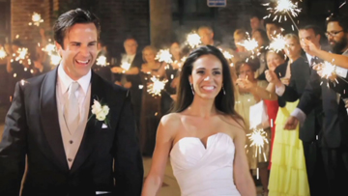
leone productions 404-312-0343 www.leoneproductions.net
120 Clarkewoods Road, Athens, Georgia 30607
Based in Atlanta and Athens… Serving all of Georgia and out of state

VIDEOGRAPHY PACKAGES

RAW FOOTAGE ONLY: on a USB Flash Drive... $150 per hour of coverage time; with 1 videographer.
You choose our start and end time, for us to capture what you want = Coverage Time!
A second videographer is available for $100 per hour; to capture for raw footage only; no editing incuded.

A FREE HIGHLIGHTS VIDEO is included with 5 hours or more of coverage time; along with Raw Footage.
A 5-10 minute Highlights video is posted on the web for you and your guests to view.

All other Videography Packages Include the following: Example of DVD/Blu-Ray Chapter Choices!

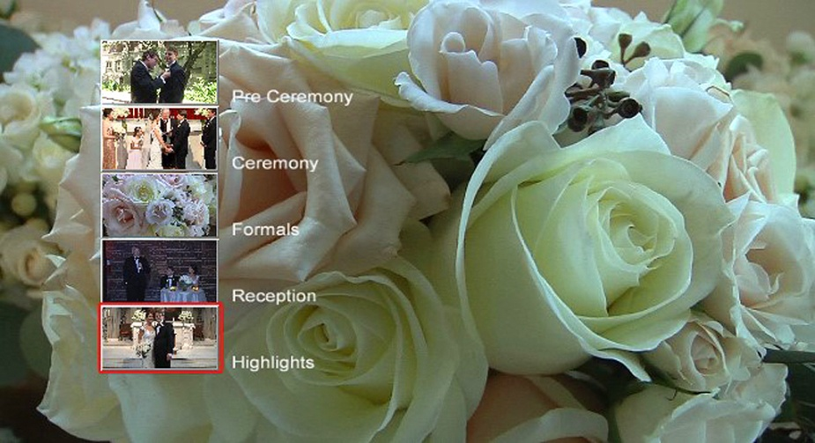

- You choose our start and end times to capture what you want...
(These become separate Chapter Choices, on your DVD or Blu-ray disk copies for instant viewing)

Pre Ceremony Coverage: Wedding parties preparing for your ceremony, guest arriving, photo shoots
Full Ceremony: Recorded with wireless lapel mic for clear audio
Formals: Candid video coverage of your photographer's Formals shoot:
This becomes a beautiful and touching video sequence, set to music of your choice.
Reception: All the highlights, plus many candid shots of you and your guests.
Highlights Video: Re-Cap Highlights video with one videographer;
Cinematic Style Highlights requires two videographers

Videography Package Pricing Next Page... Custom Packages Available...

Silver Package - $750
- 3 hours filming/coverage time (you choose our start and end time, for us to capture what you want)
- Professional editing and production of your 3 DVD or Blu-ray copies, with menu/chapter choices
- Full Ceremony as one of your chapter choices; recorded with wireless lapel mic for clear audio
- Introduction Photo Montage: still photos from your video footage, set to music of your choice
- Total length of beautiful footage with chapter choices; approximately 1 hour

Gold Package - $1,100
- 5 hours filming/coverage time (you choose our start and end time, for us to capture what you want)
- Professional editing and production of your 3 DVD or Blu-ray copies, with menu/chapter choices
- Full Ceremony as one of your chapter choices; recorded with wireless lapel mic for clear audio
- Introduction Photo Montage: still photos from your video footage, set to music of your choice
- Total length of beautiful footage with chapter choices; approximately 1 & 1/2 hours
- Add a 3-5 minute Highlights video, set to music of your choice, for an additional $250

Platinum Package - $1,650
- 7 hours filming/coverage time (you choose our start and end time, for us to capture what you want)
- Professional editing and production of your 3 DVD or Blu-ray copies, with menu/chapter choices
- Full Ceremony as one of your chapter choices; recorded with wireless lapel mic for clear audio
- Introduction Photo Montage: still photos from your video footage, set to music of your choice
- Total length of beautiful footage with chapter choices; approximately 1 & 1/2 to 2 hours
- A 3-5 minute Highlights video, set to music of your choice, is included

The Cinematic - $2,600
- 8 hours filming/coverage time (you choose our start and end time, for us to capture what you want)
- Professional editing and production of your 5 DVD or Blu-ray copies, with menu/chapter choices
- Full Ceremony as one of your chapter choices; recorded with wireless lapel mic for clear audio
- Introduction Photo Montage: still photos from your video footage, set to music of your choice
- A second videographer present to assist in capturing more cinematic style footage!
- A 3-5 minute Cinematic Highlights video, set to music of your choice, is included...
and will also be posted on-line for you and your guests to view
- Total length of beautiful footage with chapter choices; approximately 2 hours

Additional Options:

Extra DVDs: $10 per copy... Or... Blu-ray Disks: $15 per copy
PAL version DVDs available for International TVs: $95 for Initial PAL DVD format processing

Growing Up Photo Montage: From baby, to growing up years, to photos of the couple together, set to music of your choice... $2 per photo if already digitized…

Rehearsal Dinner Video Coverage: $400 minimum, up to 3 hours coverage (may include rehearsal)

An additional manned camera: $220 per hour (includes additional editing time)
(may also be needed for large number of guests or desire for many Interviews)... Please inquire for details!

Love Story Video: Tells the story of how you, the couple, met and fell in love... $500
(Video-taped and produced prior to your wedding day)

NOTE: Please let me know if there is anything else about my videography I can answer for you.
Custom video packages are also available! CONTACT: info@leoneproductions.net

Joseph Leone 404-312-0343
leone productions 404-312-0343 www.leoneproductions.net
120 Clarkewoods Road, Athens, Georgia 30607
Based in Atlanta and Athens… Serving all of Georgia and out of state

More Details: My videography packages are designed to document all the wonderful moments of your day; along with décor details and many candid shots throughout our filming time... footage of priceless memories not usually received from other videographers!

We are professional and personable while remaining a non-intrusive presence for you and your guests.

We don't just give you a 3-4 minute Highlights video as many companies are doing these days. You receive nearly all the footage; professionally edited and produced with attention to detail for your DVD or Blu-ray disks... with chapter choices, an introduction photo montage of stills I create from your video footage, a special Formals video sequence set to music; and a Highlights video, if you so choose.

You will typically receive your wedding videos in 2 to 4 weeks!

Payments: A 30% retainer fee is required to reserve our wedding videography services for your wedding day.
Balance is due on or prior to your wedding day.
Payments can be made by check, VISA, Mastercard, American Express, and Discover.

NOTE: Introduction Photo Montage, Formals Video Sequence & Highlights have Background Music of your choice! All other footage in your Chapter choices has the original video recorded audio of you and your guests!

Videography Contract / Agreement… On Next Page…

leone productions 404-312-0343 Serving all of Georgia and out of state!

120 Clarkewoods Road, Athens, Georgia 30607 www.leoneproductions.net

Wedding Videography Contract

Bride’s Name: _________________________ Groom’s Name: __________________________

Address: Where to mail your DVDs Address:

Telephone Numbers: Email Address:

Date of Ceremony: __________________________ Time of Ceremony: _________________

Name of Ceremony Location & Address: _____________________________________________

Ceremony Telephone: ________________________ My Start Time: ____________________

Name & Address of Reception Hall: __________________________________________________

Reception Telephone & Contact Name: _______________________________________________

Wedding Coordinator and Phone Number: _____________________________________________

Payment Policy: A 30% deposit is required to reserve your wedding date… Balance is due on, or prior to your wedding day.

Package Name Chosen: ___________________________ $ ________
OPTIONS and SPECIAL NOTES… Please write in below:
+Total of Options: $ ________

Total: $ ________

- Deposit: $ ________

Amount Due: $ ________

PLEASE WRITE IN HOW YOU FOUND OUR BUSINESS - FROM WHICH ADVERTISING SITE:
Thank you!

PLEASE WRITE IN SONG CHOICES & ARTISTS BELOW:

For your "Highlights Video" if your video package includes one... 1 song:

For your Introduction Photo montage... 1 or 2 songs:

For your Formals Video Sequence... 2 song choices:

Client: ______________________________ Date: ______________________

Videographer: ________________________ Date: ______________________

Please NOTE: Payments in the form of checks! If charging Payment to a Credit Card, there will be an additional service fee – Automatically charged through my Business PayPal Account! … You may book on-line through my website or call me!

Please Note: I, Joe Leone, reserve the right to have either myself or one of my in-house business videographers film your wedding. We all shoot exactly the same beautiful coverage, and I do all the editing to maintain our professional non-intrusive presence and style of production! If the videographer doesn't perform the specified duties, on time and for the agreed-upon duration, at the events specified in the contract, or provide a replacement that's just as skilled with at least 24 hours of notice, client gets a full refund within 7 business days. Videographer will also abide by all of venue's rules regarding video recording, including where recording equipment may be placed.

